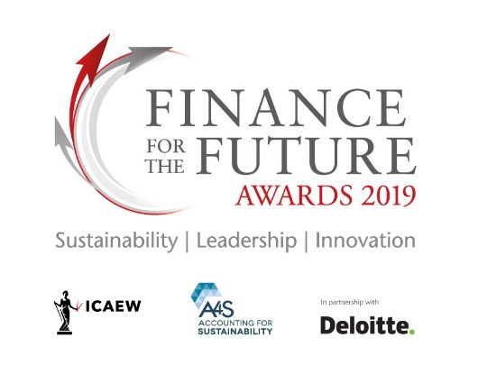
FOR IMMEDIATE RELEASE
Finance for the Future Awards 2019 finalists announced
The finalists for Finance for the Future Awards 2019 have been announced by ICAEW, The Prince’s Accounting for Sustainability Project (A4S) and Deloitte. The awards highlight good business practice, by recognising the role of finance in helping to embed sustainability issues in to decision making. Now in its eighth year, the awards ceremony will take place on 10 October 2019.

These awards are unique in looking at the crucial role financial decision makers play in creating sustainable business models. The awards show examples of leading practice and inspiring others to take action on sustainability.

The 2019 categories and finalists are:

Building sustainable financial products – Recognises organisations that have developed new financial products or services that are aimed at driving sustainable outcomes:
- Accounting for Energy (UK)
- Contact Energy (New Zealand)
- Ecology Building Society (UK)
- Octopus Investments (UK)
- Rabobank (Netherlands)
- Zigway (Myanmar)

Communicating Integrated Thinking – Recognises organisations that are demonstrating clearly, through communicating to their providers of financial capital, how sustainability is embedded into their overall strategy and decision-making process:
- ABN AMRO (Netherlands)
- Severn Trent (UK)
- S&P Global (US)
- Tideway (UK)
- Yorkshire Water (UK)
Driving change through education, training and academia – Recognises the contribution of individuals, organisations or joint-entrants in driving action to integrate sustainability through education, training and academia:
- Accounting Bissim (UK)
- Climate Change & Finance at Imperial College Business School (UK)
- CSEAR (UK)
- Harvard Business School Business & Environment Initiative (US)
- The Thinking Ahead Institute (UK)

Embedding an Integrated Approach – Recognises the finance team’s leadership in embedding integrated thinking and decision making across their organisation:
- ABN AMRO (Netherlands)
- Landsec (UK)
- Stora Enso Oyj (Finland)
- SSE (UK)
- Tata Consultancy Services Ltd (India)
- Tesco plc (UK)

Innovative project – Recognises innovative projects, led by or with the clear involvement of the finance team, that have the potential to transform an organisation into a more sustainable one:
- City of Vancouver (Canada)
- Hindustan Unilever (India)
- SteamaCo (UK)
- Sainsbury's (UK)
- Xylem (US)

Investing and financing – this award focuses on the adoption of an integrated approach across core investment and financing processes within financial services organisations:
- Carbon Delta AG (Switzerland)
- DNB ASA (Norway)
- Globalance Bank (Switzerland)
- PIMCO (UK)
- TSKB (Turkey)

Richard Spencer, Head of Sustainability at ICAEW said: “The Finance for the Future Awards process is a wonderful way to connect with, and hear the stories of people who are dealing with how they and/or their organisations benefit the planet and society as part of the way they do business. Each year we have seen a greater diversity and geographic spread of entrants demonstrating leading integrated thinking and action. This year has been no exception with an impressive field of contenders.”

Helen Slinger, Executive Director, A4S, said: "Embedding social and environmental considerations into key financial decisions can improve performance. The finalists of these Awards demonstrate why all finance leaders should be considering broader factors; for the future of the planet, society and their organisations."

Veronica Poole, global IFRS leader and UK head of corporate reporting at Deloitte, said: “This year’s shortlist demonstrates the strength that some organisations are showing in moving towards long-term sustainability. I am particularly encouraged by the number of finalists where organisations are taking action on the climate crisis. Showcasing some leading examples of those adopting integrated thinking is particularly timely in the UK – given the renewed focus on directors’ duty to promote the long-term success of their business – and should also be of interest worldwide. Integrated thinking takes into account the interests of employees, customers, suppliers and the environment, and is a growing focus for investors and policy makers.”

For more information, please visit: www.financeforthefuture.org

Media enquiries:
Contact Jude Obi, ICAEW press office, on +44 (0)20 7920 8553, or email jude.obi@icaew.com

Deborah McSkimming, A4S press office, email deborah.mcskimming@royal.uk

Notes to editors:
The awards are organised by the three partners:

ICAEW - The Institute of Chartered Accountants in England and Wales

There are over 1.8m chartered accountants and students around the world – talented, ethical and committed professionals who use their expertise to ensure we have a successful and sustainable future.

Over 181,500 of these are ICAEW Chartered Accountants and students. We train, develop and support each one of them so that they have the knowledge and values to help build local and global economies that are sustainable, accountable and fair.

We’ve been at the heart of the accountancy profession since we were founded in 1880 to ensure trust in business. We share our knowledge and insight with governments, regulators and business leaders worldwide as we believe accountancy is a force for positive economic change across the world.

https://www.icaew.com/

The Prince’s Accounting for Sustainability Project (A4S)

The Prince's Accounting for Sustainability Project (A4S) was established by HRH The Prince of Wales in 2004. Our aim is to make sustainable decision making business as usual.

We work with the finance and accounting community to:
- Inspire finance leaders to adopt sustainable and resilient business models
- Transform financial decision making to enable an integrated approach, reflective of the opportunities and risks posed by environmental and social issues
- Scale up action across the global finance and accounting community

A4S has three global networks: the Chief Financial Officers Leadership Network, a group of CFOs from leading organizations seeking to transform finance and accounting; the Accounting Bodies Network whose members comprise approximately two thirds of the world’s accountants; and, the Asset Owners Network which brings together Pension Fund Chairs to integrate sustainability into investment.

www.accountingforsustainability.org

Deloitte

In this press release references to “Deloitte” are references to one or more of Deloitte Touche Tohmatsu Limited (“DTTL”) a UK private company limited by guarantee, and its network of member firms, each of which is a legally separate and independent entity. Please see deloitte.com/about for a detailed description of the legal structure of DTTL and its member firms.

Deloitte LLP is a subsidiary of Deloitte NSE LLP, which is a member firm of DTTL, and is among the UK's leading professional services firms.

The information contained in this press release is correct at the time of going to press.
For more information, please visit https://www2.deloitte.com/uk/en.html.

